UpGameIn: 2nd part of the Library on Environmental Awareness and Circular Economy
Draft

Introduction
CHALLEDU is deeply committed to environmental sustainability both as an organisation and through the educational tools it develops. Guided by our mission to empower communities and foster positive social and environmental change, we integrate environmental awareness into our internal practices as well as our game-based methodologies. Our goal is to inspire individuals and groups to understand, engage with, and act on environmental challenges in meaningful ways.

The organization has in place a comprehensive environmental policy which leads all procedures and decisions regarding the smooth operation of the space, materials, equipment as well as behaviours and internal and external relations. By embedding sustainability into our everyday operations, we aim to reduce our ecological footprint and promote a more responsible and environmentally conscious work culture across all projects and initiatives.

Environmental education and green skills development are also core pillars of our work. Since Game Design is one of our key areas of expertise, we have designed over 15 physical, digital, phygital and escape games about environmental topics, sustainability principles, and circular economy concepts. These games empower diverse target groups (educators, youth, seniors, people with intellectual disabilities, agroentrepreneurs, communities) to explore environmental issues, build green competences, and adopt more sustainable behaviours.

Type of games and their Role in Environmental Awareness

Board games, card games, digital games, role-playing games, etc.

Guided by our values, Creativity, Innovation, Sustainability, Inclusion, Collaboration, and Empowerment, in CHALLEDU we design games that inspire environmental understanding and behavioural change while fostering key 21st-century skills. One of our key aims is to empower communities and learners through innovative educational solutions that support the Sustainable Development Goals (SDGs) and promote a sustainable, inclusive, and equitable world.

Over the years, we have experimented with a wide range of formats, such as physical (board games, card games), digital (storytelling games, educational-learning games), escape rooms, phygital games, to support environmental education- awareness and promote the principles of the circular economy, sustainability, and responsible consumption.

Physical games: Physical games align strongly with our belief that learning becomes meaningful when it is collaborative and hands-on. In our board and card games focused on environmental themes, players take on roles, negotiate solutions, and face real-world dilemmas related to agroentrepreneurship, climate change, recycling, waste management, biodiversity, or resource management. Through playing the target groups are getting familiar with the environmental issues, engaging in discussions around protection of the environment, dealing with climate change and the importance of personal choices on the general environmental footprint.

Digital games: Digital games allow a more immersive experience, where players can explore complex environmental problems safely and interactively. Thus players can gain a more complete understanding of the different environmental problems and have to sharpen their problem-solving skills. Players can witness the impact of their decisions on the environment and develop critical thinking and consumer responsibility.

Escape rooms: Escape rooms have the potential to make different age groups come together to solve problems, puzzles and riddles. They can also mirror the real time real-world environmental issues and empower players to act as a community and collaboratively overcome the challenges.

Phygital games: This type of games blend the physical form with the digital one. It can also blend the escape room- game form. This type of game can help bridging the gap between theoretical concepts of environmental education and real world practice examples.

Across all formats, our environmental games aim to:
- Promote awareness about sustainability, climate change, and circular economy principles.
- Encourage behavioural change through meaningful engagement and reflection.
- Empower communities to co-create solutions and take action.
- Develop key competencies, such as critical thinking, collaboration, creativity, and systems thinking.
- Make environmental learning inclusive and enjoyable, accessible to all ages and backgrounds.
In every game we create (especially focused on environmental education), our goal is not only to inform but to inspire participants to become active agents of environmental responsibility.

Integrating Environmental Awareness into Gameplay and Mechanics

Designing challenges and scenarios that highlight environmental problems

By using challenges and scenarios in the games that highlight environmental problems, Challedu is aiming to raise awareness and make the player contemplate on real problems that affect our planet and the environment. These scenarios are not necessarily realistic according to the actual facts about environmental issues. For different games, scenarios can be more realistic or more fantastical. However, having problems or issues that the characters or the players confort being connected to environmental issues can have a great impact on people’s way of thinking.

Encouraging sustainable behaviors through in-game decisions

Similarly with designing challenges and scenarios that highlight environmental problems, encouraging the players to take actions and accumulate sustainable-related behaviours can also have a great impact through the games.

Examples of mechanics that promote ecological thinking

Some examples that can be used in game designing to increase environmental and ecological thinking through challenges, scenarios and actions of players can be: giving players positive points when doing something environmentally friendly in the game, retracting points when doing something negative to the environment in the game and so on.

Environmental themes and messaging in games

How environmental topics are incorporated into gameplay

Challedu is pioneering in research and development of Serious and Educational Games. Essentially, serious games are designed to offer gamified knowledge, so through the playing process, the players have the opportunity to gain new skills and competences related to this topic. After having supplied the players with the knowledge on a specific topic, serious games take it a step further by trying to motivate people to take action and create change in real life. This is cultivated through providing awareness about a topic, the appropriate tools and techniques, thus creating motivation and confidence to the player so, after playing the game, they are invested or at least well informed on various topics and they want to act, to take the game to real life. Regarding environmental topics, Challedu has created numerous games related to environmental topics with great success. Challedu has used the methodology of Serious Games to create games about social and environmental Issues. Some examples of these games are GrandFriend and Agricharisma.

Educational aspects about sustainability

Similar to serious games, Challedu has also used Game Based Learning (GBL) to enhance the educational value of the games we design. Game Based Learning is the concept that within a game, the game characteristics are adjusted to educate the player on a lesson, or pass on information on a specific topic. In simpler words, the games are used with a goal that the gamer will achieve certain learning objectives and will be assessed on them, while playing the game. With the idea that the player will retain certain information after the game, GBL is a great method to incorporate in games that want to promote environmental awareness and action in real life.

Through various Erasmus+ projects we have touched on the topics of environmental awareness either as the main scope of the games, or within the game scenarios. Thus, we have designed educational games in physical or digital form. More specifically, through the projects AntiRumour, GrandFriend and Agricharisma, we have created digital games that incorporate Game Based Learning and serious games design methods. AntiRumour is a serious game in physical form (board game) that aims to educate and shield young people on the topic of fake news, actively helping them to recognise the fake news through the gameplay process. The game has various scenarios with climate change, ecological and green practices, that guide the player to perform a brief research on the given topic, gather facts and support the truth-or work against it, according to their role within the game. In any case, it gives an incentive to the players to act on similar topics, firstly in the game and then in everyday life. The GrandFriend game is a GBL online game that aims to bring together younger and older farmers and train them on the topics of Agriculture and sustainable practices. Similarly, Agricharisma is targeting young people that want to start their own Agro-Business and through the gameplay, it aims to develop their skills in the field of Agro-entrepreneurship and give the young entrepreneurs useful insights on how they can build their own Agro-Business.

Player engagement with environmental themes

Through disseminating the games, we have connected with farmers across Greece and the world, in order to spread awareness about environmental education and sustainable practices that go beyond the game itself and motivate the players to act in their own life.

Impact and Educational Effectiveness of Games

How does your organization measure a game’s effectiveness in promoting environmental awareness?
The testing of the games is implemented through playtesting sessions in working groups that consist of the target groups of different ages, either in physical attendance or in the cases that said target groups are not able to physically attend these workshops, in online sessions. In the cases of the games mentioned above, we also provided the farmers with online educational e-courses as part of the projects. The participants of the playtestings or trial of the games are given questionnaires to answer about how they liked the games. After the game has been finalized and published through all platforms, the games are disseminated and shown to the audience and for the general public. Through disseminating the games, we have connected with farmers across Greece and, across the world, in order to spread awareness about environmental education and sustainable practices that go beyond the game itself and motivate the players to act in their own life.

Player feedback and behavior change as a result of gameplay
To ensure the best quality of the games we are designing we receive feedback throughout the game creation process. People from the respective target groups try the Beta version of our games, in order to change features, information or other types of graphics that might be irrelevant to the target groups and to our final aim. Then they answer questionnaires, or participate in focus group interviews and reflection sessions to make sure we are all on the same level of understanding. These processes are taking places during various phases of the game, until its final version.

Case studies on the impact of educational games
-GrandFriend
-Agricharisma

Collaborations and Community Engagement

Partnering with environmental organizations for game content and promotion
Challedu has taken part in more than x projects in Erasmus+ and other funding institutions. This way Challedu has created a large pool of organizations that has a solid partnership with. Some of these organizations are also environmental organizations. Through these partnerships, we are able to gain insights from organizations that are specialized to the subject of the environment, as well as advice on what information is more important to include in the game content. Moreover, these organizations are the perfect group to promote the games we are designing, as they will be helpful for the aim they are trying to achieve. It is very important for organizations to collaborate with each other and see what they can learn from other organizations with different specializations.

Encouraging community involvement and activism through game-based initiatives

Challedu’s aim is to encourage community involvement and activism by fabricating games that advocate for environmental awareness and sustainability. The games GrandFriend and Agri-Charisma that use serious games and game-based learning methodologies, deal with real-world themes such as rural entrepreneurship and sustainable agriculture. Besides teaching players about different topics, these games also motivate them to look at their environment and take action in their daily lives. With this, the games have a tangible impact. Throughout the game design development process, minorities and diverse groups’ voices are taken into account, making the games more inclusive and the social and environmental impact more exponential.

Leveraging social media and multiplayer aspects to spread awareness
Social media is very important nowadays. Most young people gain their information and facts from social media. Challedu’s uses social media to promote our games as well as events to play games in our premises. By sharing our games and small videos on how they are played we aim to attract people and raise awareness for our work in all Greece and worldwide.

Conclusions/recommendations for the target audience

When designing games where we want to promote action on environmental issues through the gameplay, the game designers should focus on choosing the method they will follow when designing the structure of the game. Some methodologies Challedu has used are serious games and Game Based Learning games, among others. When focusing on a specific topic, always perform extensive research on it, focus on the actions that a person can take in real life and gamify them through the game. Playtestings are also an important part of designing games in order to see how the games affect or are liked by the target audience. Last but not least, it is important to focus and give space to the target groups, giving them space to talk about their personal experience, in order to give an authentic experience to the player.

Best Practices (Examples for Environmental Practices)

Alba: A Wildlife Adventure

Name/title: Alba: A Wildlife Adventure
Webpage/source: | Alba: a wildlife adventure by us two games
Company or organization that has developed the game | UsTwo Games
Type of game | Digital game that can be played on Nintendo Switch, PlayStation 4, PlayStation 5, Xbox One and Xbox Series X/S, PC, Apple Arcade.
Description (about 1000 characters including spaces max) | What is the game about?  While visiting her grandparents on an island, Alba (the player) is fascinated with the local wildlife and she wants to protect it. She takes on various tasks such as cleaning the trash, rescuing animals and documenting biodiversity. The goal of this game is to assemble the locals and save the island’s environment reserve.  How does it promote environmental awareness?  The game introduces ecological concepts and motivates the players to take similar actions in their everyday life, while informing about the impact of human activities on nature.  How does it use gamification for environmental activism?  Players have to complete environmental quests that lead to rewards like further story progression and support to Alba’s causes from the locals.  What kind of engagement mechanics are used (e.g., challenges, leaderboards, storytelling, social sharing)?  Challenges: Players have to complete environmental quests  Storytelling:The narrative that intertwines ecological issues, culture and community.  Social Engagement: Alba has to persuade NPCs to sign a petition, in order to promote on the sense of cooperation and team action  Progress Tracking: Yes  Impact examples or success stories  Article on the impact of the game
Environmental Features Checklist | Promotes direct environmental action  Uses gamification to encourage long-term engagement  Offers real-world incentives for participation
Images (1/good practice) | 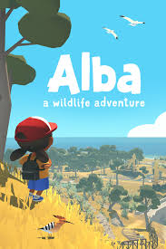

Beyond Blue

Name/title BEYOND BLUE
Webpage/source: | www.chaostheorygames.com
Company or organization that has developed the game | Publisher/Designer: E-Line Media
Type of game | Digital/Video game
Description (about 1000 characters including spaces max) | What is the game about?  Beyond Blue is a videogame about the opportunity to explore the mysteries of our ocean through the eyes of Mirai, a deep-sea explorer and scientist. She and her newly-formed research team will use various technologies to see, hear, and interact with the ocean in a more meaningful way than has been attempted in the past.  How does it promote environmental awareness?  The game encourages the player to learn and reflect on the vastness of the ocean thanks to scanning aquatic creatures. It also contains sixteen unique mini documentaries, called "Ocean Insights," featuring original footage and interviews with leading ocean science experts. The goal is to foster a deeper connection with the ocean and inspire players to learn more about protecting marine life and ecosystems.  How does it use gamification for environmental activism?  It incorporates educational content and conservation messages as it emphasizes the need for sustainable practices to protect the seas, a partnership with OceanX that provides research on ocean exploration, and the will to engage a broad audience by blending entertainment with environmental education. It encourages players to think about their role in ocean preservation.  What kind of engagement mechanics are used (e.g., challenges, leaderboards, storytelling, social sharing)?  Players have missions that they have to complete to move the story forward and unlock more info. There is storytelling involved to connect players with the topic. Players get to pick how Mirae responds in conversations. They can explore the underwater worlds and everytime they scan an animal, it gets added to their Science Log. As players progress in the game, real educational videos from the TV Show Blue Planet are unlocked. There's a Free Dive mode that players get to play after finishing the story.  Impact examples or success stories  The game has more than 10 million players worldwide and awards from Indiecade and Jackson-Wild. It has helped connect people with the ocean and inspired the next generation of ocean scientists.
Environmental Features Checklist | Promotes direct environmental action  Uses gamification to encourage long-term engagement  Offers real-world incentives for participation  Enables community-driven initiatives  Integrates real environmental data: The CO2 index in the game
Images (1/good practice) | 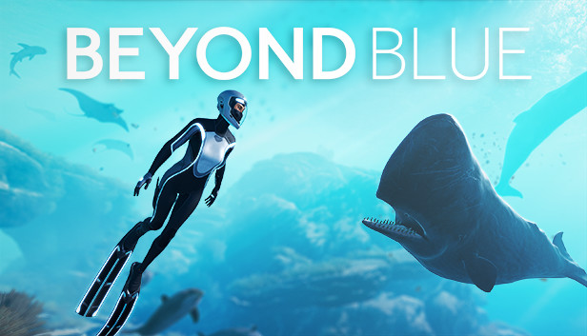

Lost City of Mer

Name/title Lost City of Mer
Webpage/source: | LOST CITY OF MER Home | The Lost City Of Mer
Company or organization that has developed the game | Astrea Media
Type of game | VR, mobile
Description (about 1000 characters including spaces max) | What is the game about?  The game is about exploring the ocean and the underwater civilization called “Mer”.  How does it promote environmental awareness?  You swim and explore the devastating effects of acidification and ocean temperature rise. You can undertake some actions eg. planting coral. The more you play and take care of the Mer ecosystem the better it gets.  How does it use gamification for environmental activism?  The game shows how the ocean’s ecosystem changes when you undertake actions to lower the carbon footprint or the acidification. In the gameplay you can find “science bubbles” that share some scientific info eg. coral reefs environment or carbon cycle. You can win rewards and unlock new adventures for walking instead of driving (You have to have a downloaded app and carry your phone with you.) Moreover, you learn how much CO2 is released when you drive and how much you “save” when you are walking.  What kind of engagement mechanics are used (e.g., challenges, leaderboards, storytelling, social sharing)?  - Instagram profile for the community Lost City of Mer 🐳 (@lost_city_of_mer)  - the more you walk, the more rewards and adventures in the game you unlock.
Environmental Features Checklist | Promotes direct environmental action: Walking instead of using transport means.  Offers real-world incentives for participation  Enables community-driven initiatives: Instagram account for community  Integrates real environmental data: The CO2 index in the game
Images (1/good practice) | 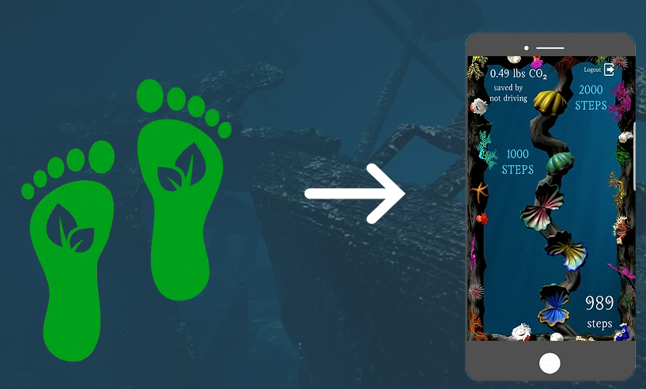

Circular Economy Game Design Methodology

Types of games designed
Games we have designed for this

Considerations in material selection and production regarding circular economy

Material choices (upcycling, recycling, repurposing)
When the game content has been finalised, what’s left is the packaging.
Motivated by its Green Policy and with care for the environment, Challedu follows two main options to minimise waste in game production. The first one is that the games we create are print-on-demand, meaning that the player has to download and print if they want to play the game. The second option is that when we have to eventually print the games, we try to print only on recycled paper, avoid plastic as much as possible and print on the back side of pages that have been left unused. An alternative option we have been introducing for the past few years is to motivate the people interested in playing our games, to contact us so we can lend them the board game or games they are interested in for their play sessions.
Concerning the packaging decisions, we stress that the packaging of the board games is made from recycled paper and are not plasticised but cardboard-like.
While in the production phase, our game designer team is trying to focus on specific aspects such as the value of the game we are creating and thus printing, in order to produce a game that will last and will not be discarded after its first or first few uses.

Packaging decisions
-Cupboard boxes for the packaging og the board games. Avoid using plastic besides the necessary to ensure the cards wont be damaged. Moreover we do not print many games in order to avoid waste and only print upto demand or we have the games available for the audience to download on their own choice of material.

Production methods and their use of circular economy principles
Complete

Circular economy themes and messaging in games

How circular economy topics are incorporated into gameplay
In order to touch upon the topic of circular economy, we have incorporated aspects of practices that approach circular economy such as: Sustainable practices, Waste management and Environmental protection in the field of Agriculture at the GrandFriend game as well as in the Agro-Edu Games.

Educational aspects about circular economy
Complete

Player engagement with circular economy themes
Complete

Testing and evaluation

Circular economy impact assessment of production
complete

Carbon footprint calculations
complete

Lifecycle analysis
complete

Distribution and end-of-life considerations

Digital vs. physical distribution methods

Regarding the distribution of our games, we have different practices concerning the digital and physical games. For digital games, in order to avoid creating extra packaging in the types of cases for cards, usb sticks etc, we aim to upload our games on our website and websites of the projects if there are, in downloadable or ready to play form. Moreover, the board games we create, we try to upload on platforms like Tabletopia where the public can easily access the games.

Regarding the physical games, the distribution method we mainly follow is to print on demand. We have 1-2 copies in our office for play sessions, or for lending those to people and if needed, in the case we are attending events with a large number of players, then we print more copies of the game. After these events, what we usually do is donate said board games to other organisations that usually organise play sessions or are passionate about playing board games.

Upcycling and other instructions pertaining to reuse and repurpose the game materials

Second-hand market support

Conclusions/recommendations for the target audience
In Challedu we strive to focus on Circular economy practices, similarly with the environmental awareness topic. When creating games, we aim to inform players on the topic of Circular economy, provide them with the adequate input so they can further investigate sustainable solutions and introduce the concept of circular economy in their personal lives and businesses where applied. Regarding our organisation’s practices, as mentioned above we follow the United Nations Agenda that was adopted by the UN in 2023 and contains the 17 Sustainable Development Goals (SDG) that are applicable to our own course of action and line of work.

Best Practices (Examples for Circular Economy)

Circula
Name/title Circula
Webpage/source: | https://circula.fi/en/
Company or organization that has developed the game | SYKLI
Type of game | Board game
Description (about 1000 characters including spaces max) | What elements of circular economy are present in the game’s design & production cycle?  Circula is an educational game created to introduce players to the world of circular economy and entrepreneurship through interactive workshops and activities.  Players experience a simulated economy based on the principles of the circular economy.  It presents several challenges such as designing sustainable products, managing waste, and optimizing resource use.  Players are continuously in contact with terms such as “recycling” or “upcycling” and they are asked to make decisions to create a durable product or to come up with new ideas to reduce waste or environmental footprint.  How does the design of the game and its theme/topics align with the ideas of circular economy?  It utilizes a practical approach to dive into the subject of sustainability and entrepreneurship, fostering skills and knowledge essential to promote a circular economy.  Participants work in teams to develop business ideas based on circular economy principles, using their skills and available resources.  How do these games find their way to the used games market or are otherwise repurposed?  The game includes advanced assignments to get to know circular economy concepts.  "Circular Economy Walk" introduces players to real-world applications and inspires creative thinking.
Circular Economy Features Checklist | Sustainable materials  - Players select raw materials from renewable resources (e.g., bamboo, hemp) or recycled materials (e.g., plastic, paper, metals).  Minimal or degradable packaging  - The design is durable, repairable, and modular (e.g., products with replaceable parts.  Circular economy education elements  - Recycling  - Materials and products are used as long as possible  - Minimalistic design to reduce waste and excess
Images (1/good practice) | 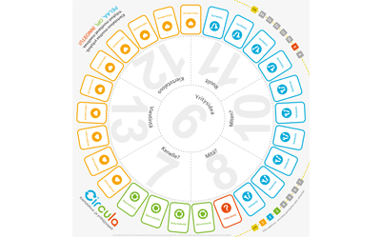

Terra Nil
Name/title Terra Nil
Webpage/source: | Terra Nil | Available now on Nintendo Switch, PC & Netflix
Company or organization that has developed the game | Free Lives
Type of game | Digital game that can be played on PC, Nintendo Switch and Netflix Games
Description (about 1000 characters including spaces max) | What elements of circular economy are present in the game’s design & production cycle?  As a game focused on nature restoration, players are asked to reconstruct deserted landscapes. All the infrastructure is demolished at the end of each level, in order to have no trace of human activity. The game encourages long-term changes in behaviour for its players, through environmental education. Therefore, it encourages circular economy thinking.  How does the design of the game and its theme/topics align with the ideas of circular economy?  The game’s design raises awareness of ecological balance and restoration. This can encourage players to reflect on how regenerative practices in the game can be applied to the real world. These features in the game, align with circular economy principles.  How do these games find their ways to the used games market or are otherwise repurposed?  The focus on digital platforms minimizes the environmental waste that is associated often with the games market.  Impact examples or success stories  Tangible environmental restoration efforts have been achieved through the partnership with the One Tree Planted, which plants trees for every game sale.
Circular Economy Features Checklist | - Sustainable materials  It is a digital game so it doesn't have physical packaging  - Circular economy education elements -Terra Nil is designed around environmental restoration, which inherently teaches principles of sustainability.  - Carbon-neutral production  Terra Nil has partnered with One Tree Planted, a non-profit organization dedicated to global reforestation efforts. Through this partnership, the developers have committed to planting trees for each copy of the game sold.  Other (please specify)
Images (1/good practice) | 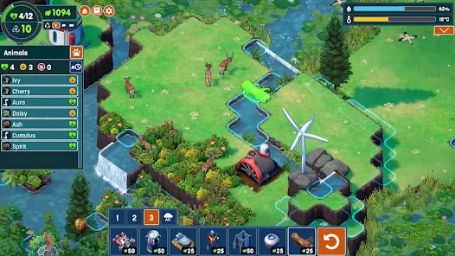

Recycle Rally
Name/title Recycle Rally
Webpage/source: | Recycle rally | Adventerra Games
Company or organization that has developed the game | Adventerra Games
Type of game | Board game
Description (about 1000 characters including spaces max) | What elements of circular economy are present in the game’s design & production cycle?  All of the elements of the game are recyclable and recycled, 100% plastic-free, vegetable inks (kids-safe and non-toxic), made in Europe (reduced carbon footprint).  How does the design of the game and its theme/topics align with the ideas of circular economy?  In the gameplay players move across the board and collect recyclable trash to transport them to recycling centers. In this way they learn the importance of recycling and how the whole process looks like.  How do these games find their ways to the used games market or are otherwise repurposed?  You can find many people selling the “Recycle rally” that they bought before on eg. eBay, Facebook, Vinted etc.  Impact examples or success stories  Recycle Rally is STEM.org authenticated and has won 10 awards, including the Toy Insider 2021 Top Holiday Toys Award, the Mom’s Choice Gold Award, and The National Parenting Center Seal of Approval.
Circular Economy Features Checklist | - Sustainable materials: All of the elements are made of sustainable materials.  - Minimal or degradable packaging: Eco-friendly packaging 100% plastic-free.  - Digital distribution & second-hand market life: You can find many people selling the “Recycle rally” that they bought before on eg. eBay, Facebook, Vinted etc.  - Circular economy education elements: Recycling process  - Carbon-neutral production: Made in Europe - reduced carbon footprint
Images (1/good practice) | 